

Practices for Secure Software Report

Table of Contents
Document Revision History 3
Client 3
Instructions 3
Developer 4
1. Algorithm Cipher 4
2. Certificate Generation 4
3. Deploy Cipher 6
4. Secure Communications 7
5. Secondary Testing 7
6. Functional Testing 8
7. Summary 9
8. Industry Standard Best Practices 9

Document Revision History

Version | Date | Author | Comments
1.0 | 12/13/2025 | Joseph M. Opheim | Updated version

Client



Instructions

Submit this completed practices for secure software report. Replace the bracketed text with the relevant information. You must document your process for writing secure communications and refactoring code that complies with software security testing protocols.

- Respond to the steps outlined below and include your findings.
- Respond using your own words. You may also choose to include images or supporting materials. If you include them, make certain to insert them in all the relevant locations in the document.
- Refer to the Project Two Guidelines and Rubric for more detailed instructions about each section of the template.

Developer
Joseph Opheim

Algorithm Cipher

Brief Overview of the Encryption Algorithm Cipher
SHA-256 (Secure Hash Algorithm 256-bit) was chosen to accommodate the requirement of Artemis Financial of a very powerful checksum verification. SHA-256 is a cryptographic hash algorithm designed to output a fixed 256 bits given any size of data, thus it is applicable in verifying integrity under a one way security (Ali, 2023). This implies that after data has been hashed, then the data is irreversible, irretrievable, and this safeguards confidential data in the validation process. It is very reliable hence it can be used in financial systems where consistency and resistance to alteration are needed.
Hash Functions and Bit Levels
SHA-256 produces a 32-byte (256 bits) output and digests data in 512-bit blocks (Algredo-Badillo et al., 2022). The hash output is a 64 character hexadecimal number which is consistent with the same input. Such high hashing power provides a high level of security against collision whereby two distinct inputs give the same hash. Due to this, SHA-256 is still a highly trusted tool in the verification of financial data.
Random Numbers and Symmetric vs. Non-Symmetric Keys
SHA-256 is not a random based generator and is deterministic. Nevertheless, secure implementations typically use it in conjunction with encryption schemes like the Secondary Security Layer protocols of the SSL/TLS, which are based on asymmetric encryption, e.g. RSA exchanges keys. After exchange of keys, data can be sent by applying symmetric encryption. Cryptographically secure random numbers play a key role in this configuration to produce key pairs of RSA and enhance the security of the entire system.
History and Current State of Encryption Algorithms
The NSA created SHA-256 and published it in 2001 as a part of the SHA-2 family as a substitute to the compromised SHA-1 algorithm (Sadeghi-Nasab & Rafe, 2023). As of 2025, SHA-256 is an industry standard of data integrity verification with no known feasible attacks (Ali, 2023). SHA-256 is mandated or heavily suggested in many compliance standards, such as PCI DSS, HIPAA, and FIPS 140-2. Consequently, it remains reliable in financial applications which have to be capable of meeting current security standards.

Certificate Generation
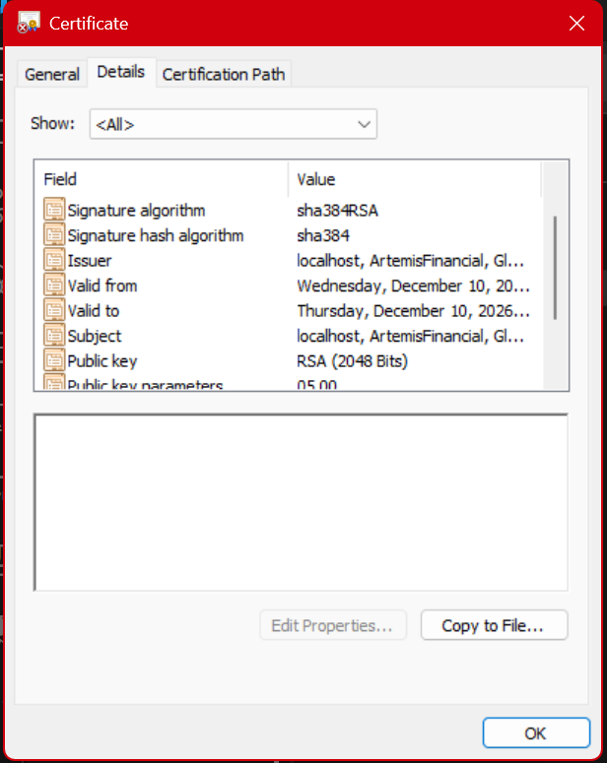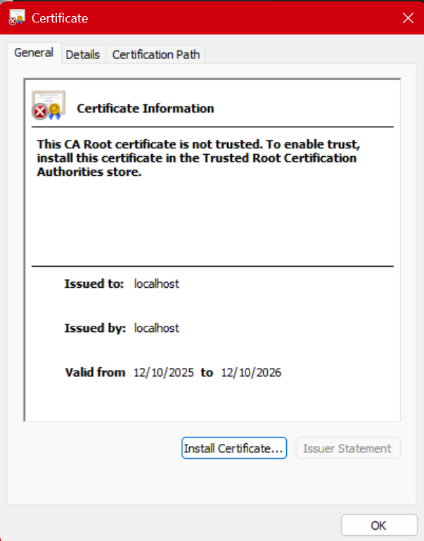

Deploy Cipher
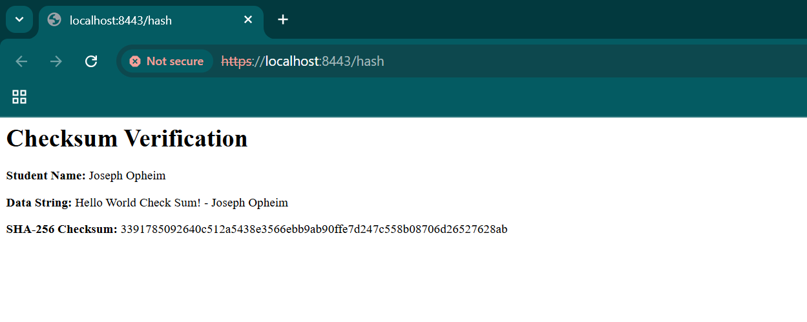

Secure Communications

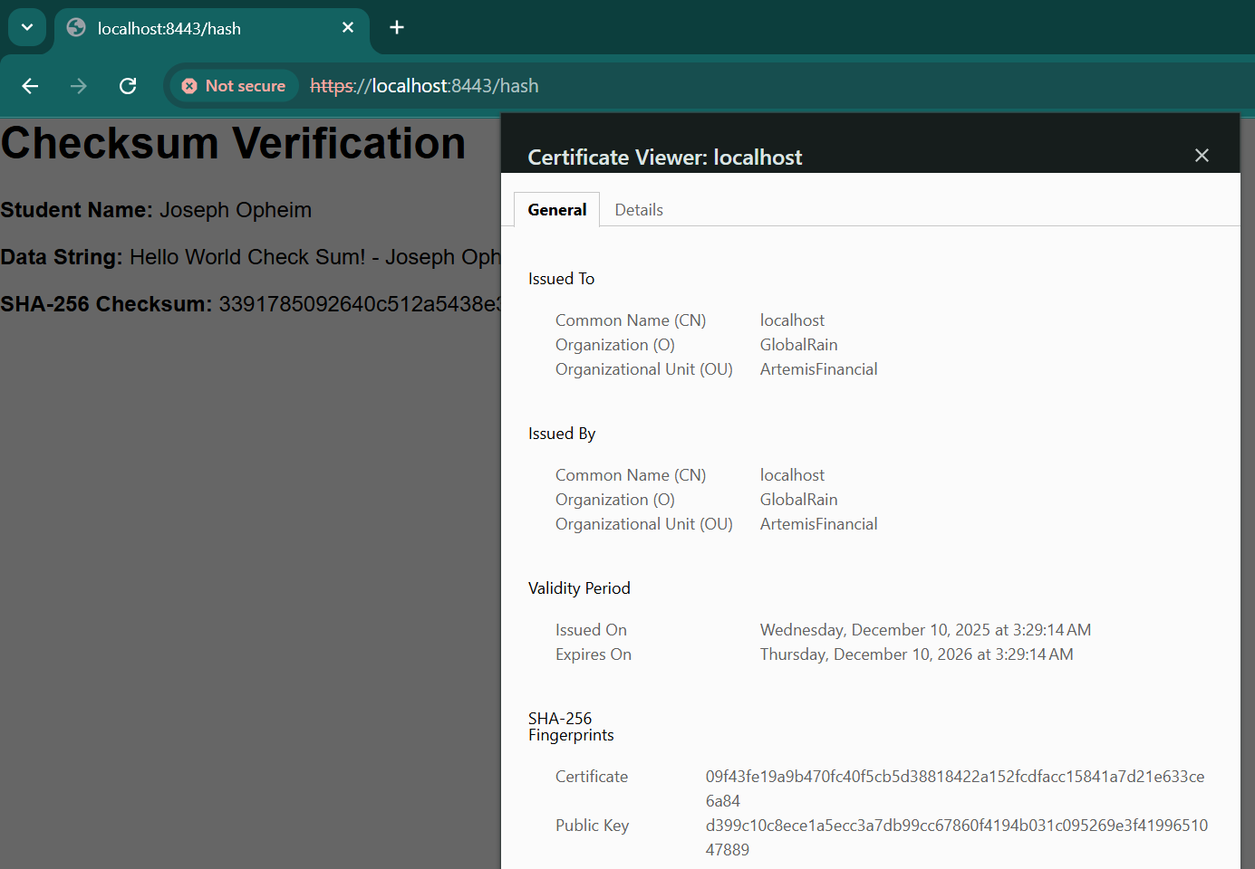

Secondary Testing

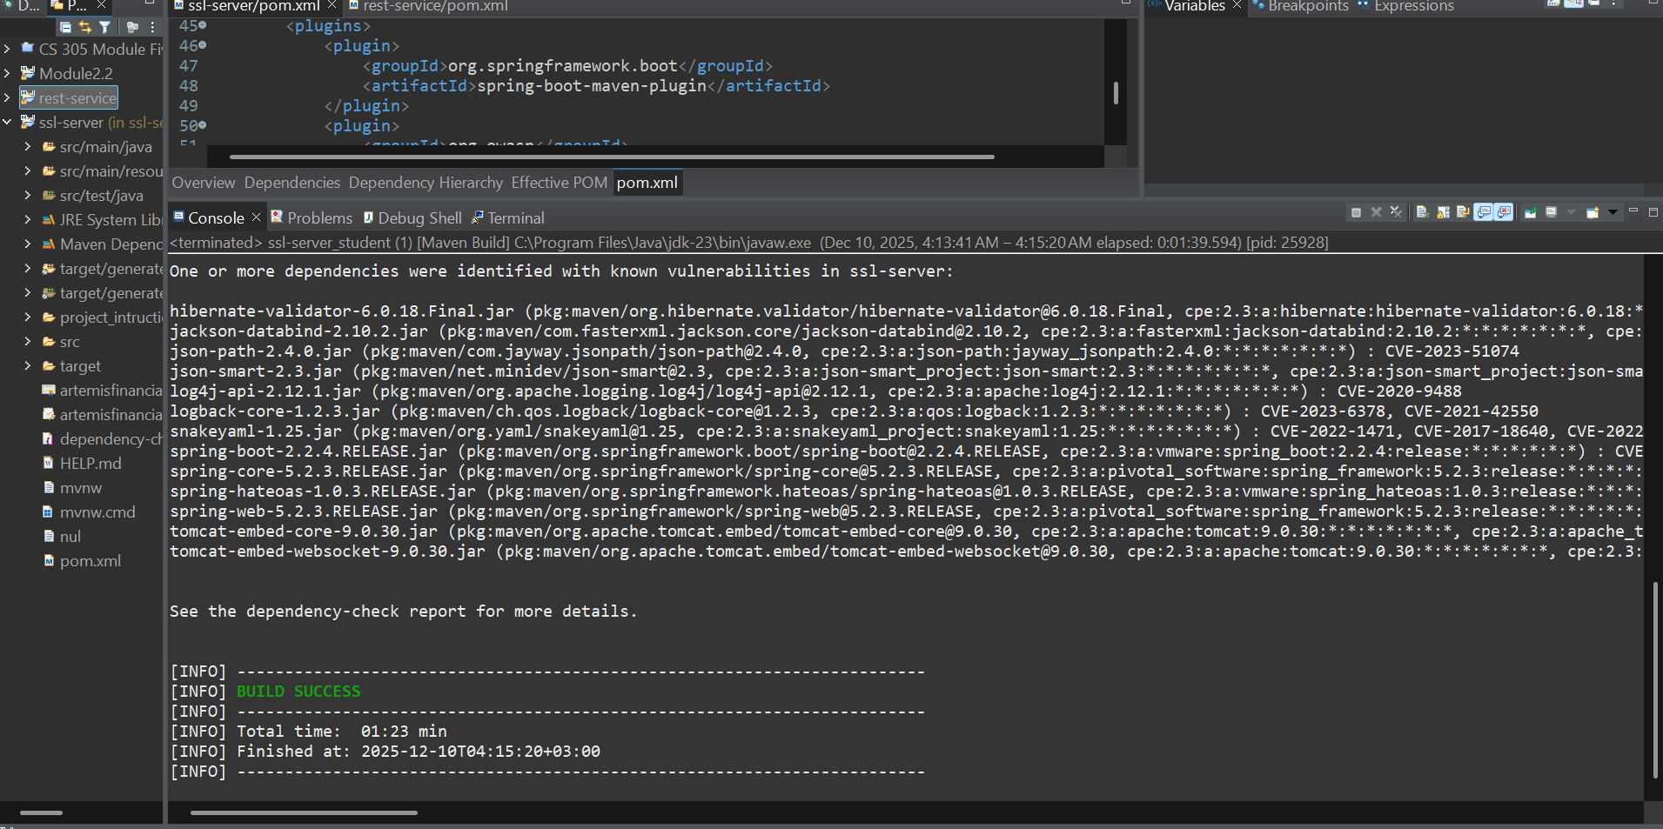

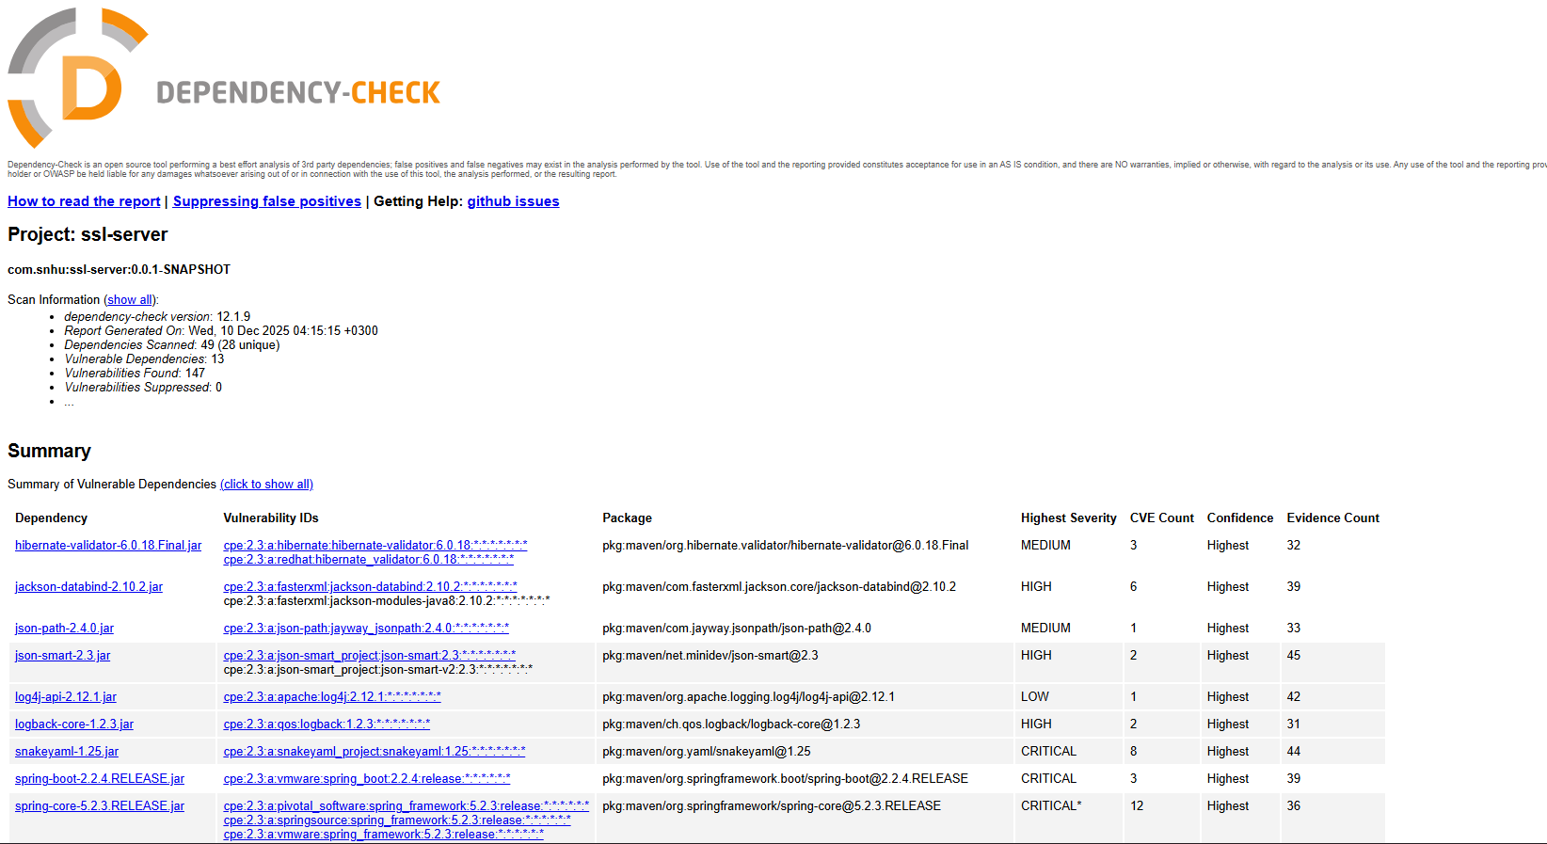

Functional Testing

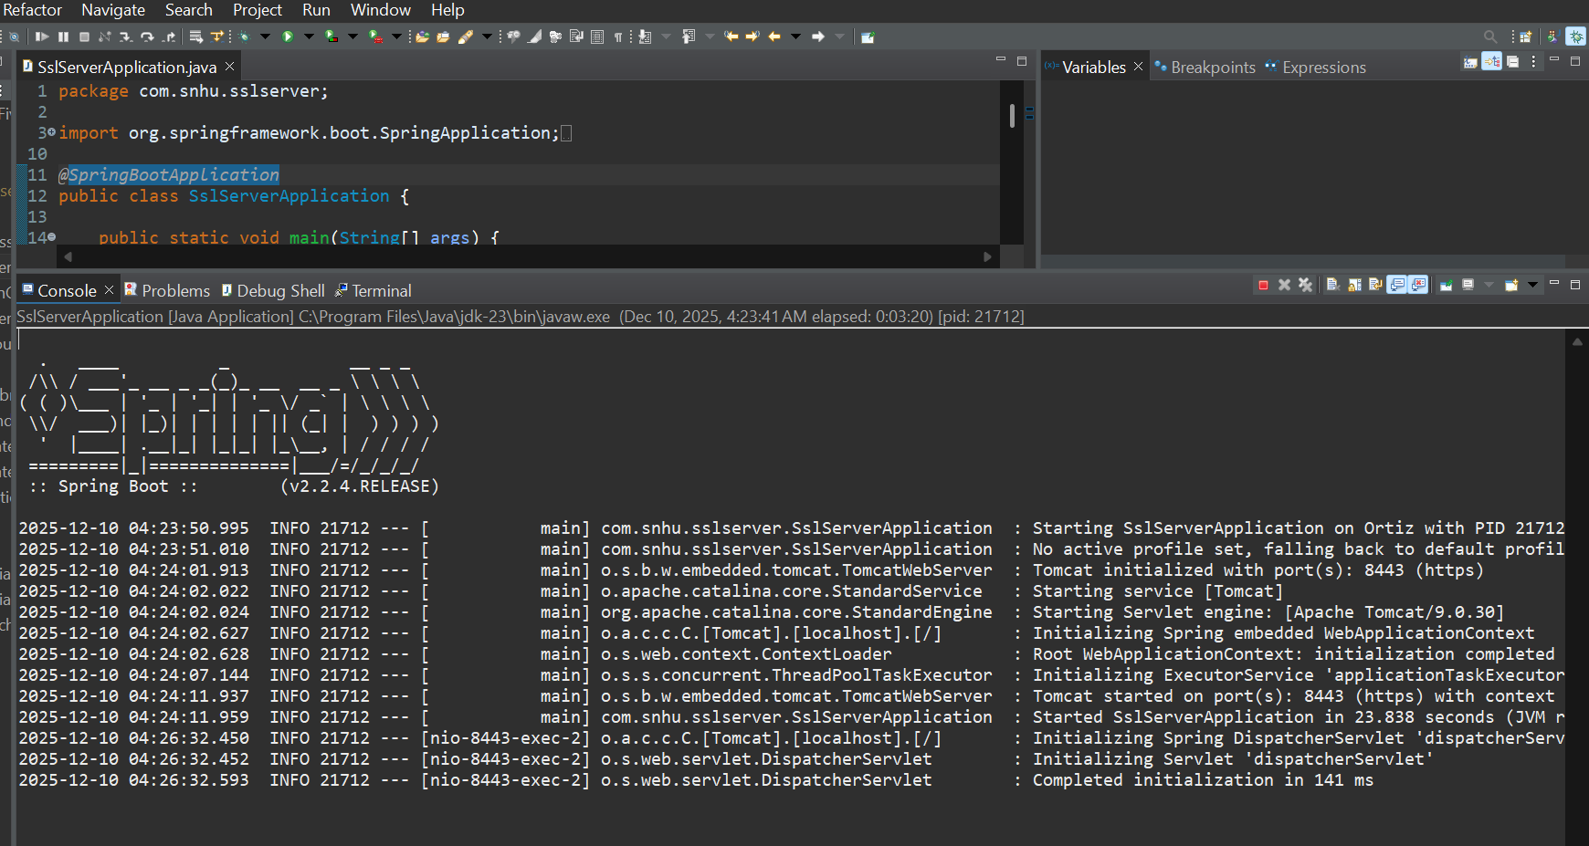

Summary

Areas of Security Addressed (Vulnerability Assessment Process Flow Diagram)
In reference to vulnerability assessment process flow diagram, the following security domains were covered during the refactoring process:
- Cryptography: Installed Data integrity checks with the help of hash SHA-256.
- Client/Server Architecture: Secure HTTPS communication configured over port 8443 with SSL/TLS encryption.
- API Security: Removed the plaintext transmission of data through the imposition of HTTPS protocol.
- Best Practices of Secure Coding: made use of Java standard cryptography and exception management.
Process for Adding Layers of Security
The defense-in-depth approach was implemented in layers to enhance the system security. First, TLS was enabled to ensure that the data is not compromised in transit. Secondly, the integrity of data was verified by means of a SHA-256 checksum to identify any unauthorized modifications. Third, they minimized security risks by making use of familiar Java SE standard libraries, as opposed to the use of third-party dependencies. Lastly, automated static analysis using OWASP Dependency-Check was introduced such that no new vulnerabilities were added as a result of refactoring.

Industry Standard Best Practices

The application security posture was enhanced by practicing best practices in the industry. OWASP Secure Coding Practices guided the refactoring, emphasizing the use of built-in platform cryptographic tools such as java.security.MessageDigest instead of custom implementations prone to flaws. The native support of Spring Boot with SSL/TLS was applied to support HTTPS without altering any sensitive framework properties. The principle of minimal dependencies was observed to reduce the attack surface, and security parameters were externalized into the application.properties file to allow configuration updates without recompiling code.
Value to Company’s Overall Well-Being
Implementation of industry practice of secure code gave Artemis Financial considerable advantages. SHA-256 allows the organization to comply with the requirements of PCI DSS, HIPAA, or SOC 2 and prevent fines imposed by the regulators. These also decrease the risk of data breach which helps to guard the reputation of the company and minimizes the chances of legal or financial repercussions. OWASP Dependency-Check Automated security testing can help optimize the operation of an organization by eliminating the contextual audits and offering demonstrable evidence of security practices. All these practices enhance customer trust and provide Artemis Financial with a competitive edge when dealing with customers that have high security requirements.

References
Ali, A. Z. M. (2023). The Power of Cryptography: Hashing and Encryption for Data Protection. J Artif Intell Mach Learn & Data Sci, 1(1), 1857-1861. https://urfjournals.org/open-access/the-power-of-cryptography-hashing-and-encryption-for-data-protection.pdf
Algredo-Badillo, I., Morales-Sandoval, M., Medina-Santiago, A., Hernández-Gracidas, C. A., Lobato-Baez, M., & Morales-Rosales, L. A. (2022). A SHA-256 hybrid-redundancy hardware architecture for detecting and correcting errors. Sensors, 22(13), 5028. https://www.mdpi.com/1424-8220/22/13/5028
Sadeghi-Nasab, A., & Rafe, V. (2023). A comprehensive review of the security flaws of hashing algorithms. Journal of Computer Virology and Hacking Techniques, 19(2), 287-302. https://link.springer.com/article/10.1007/s11416-022-00447-w

Appendix: Code Files Modified
The following source code files were modified or created as part of this security enhancement project and are attached to this report:
Modified Files:
- SslServerApplication.java - Primary application file with added HashController class implementing SHA-256 checksum verification endpoint
- application.properties - Server configuration file updated with SSL/TLS parameters for HTTPS enablement
- pom.xml - Maven project configuration updated with OWASP Dependency-Check plugin version 12.1.9 and NVD API configuration
Generated Files:
- artemisfinancial.p12 - PKCS12 keystore containing self-signed SSL certificate and private key
- artemisfinancial.cer - Exported certificate file for documentation purposes
File Locations:
- Source code: src/main/java/com/snhu/sslserver/SslServerApplication.java
- Configuration: src/main/resources/application.properties
- Build configuration: pom.xml
- Certificates: Project root directory

